Career Coach can help you:

* discover potential careers based on your interests and strengths
* browse relevant data on wages, employment and training
* preview TCC programs that will provide an educational path for your chosen career
* build and deploy a professional resume
* help military veterans explore civilian careers

To access Career Coach, go to: <https://tidewater.emsicc.com/>

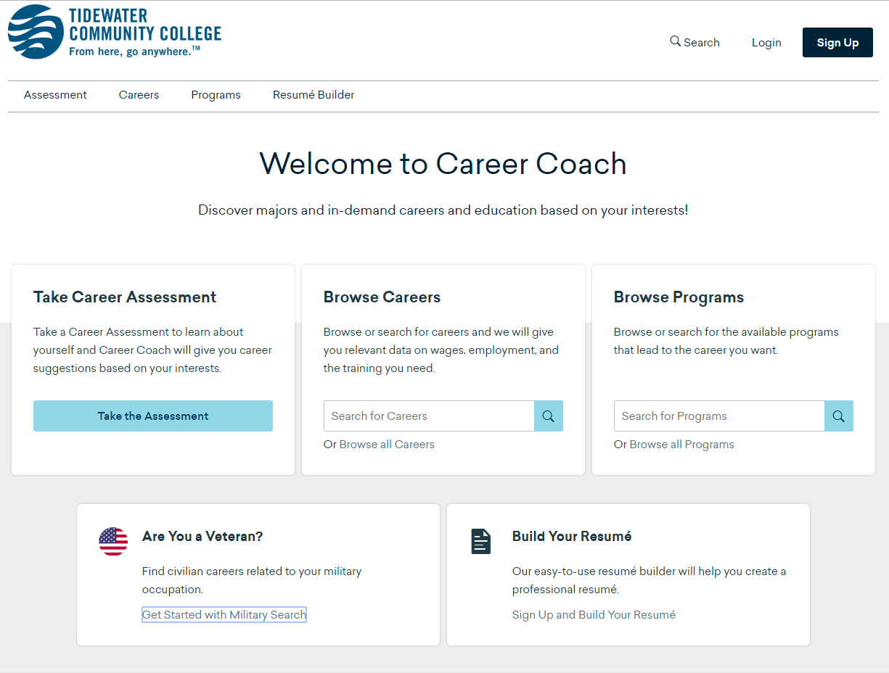

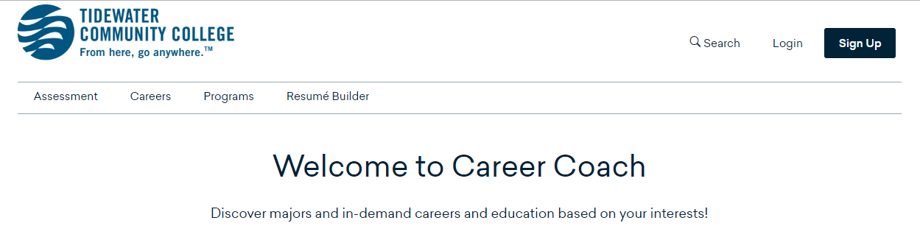

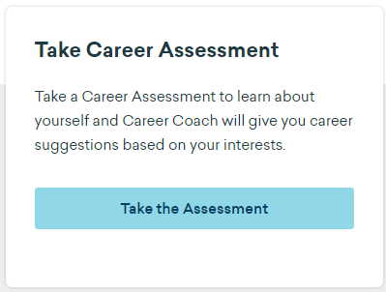

**For personalized career matches, select the “Assessment” tab in the menu pictured above or click the “Take the Assessment” button in the “Take Career Assessment” box.**

**Select the 60 question assessment.**

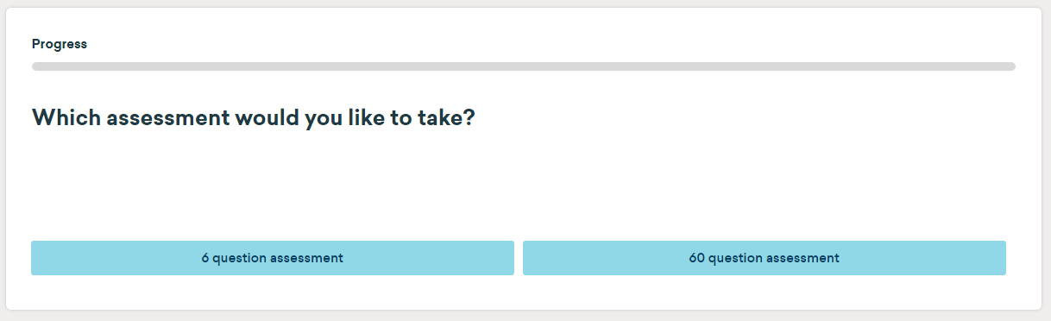

**Your assessment results will provide an in-depth analysis of your top traits and career matches.**

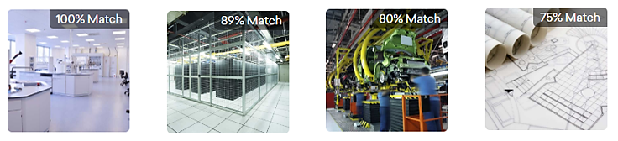



**After completing your assessment click “Sign Up” to create an account, save your results and** **build a resume you can download and edit anytime -- and upload to CareerBuilder® to begin your job hunt.**

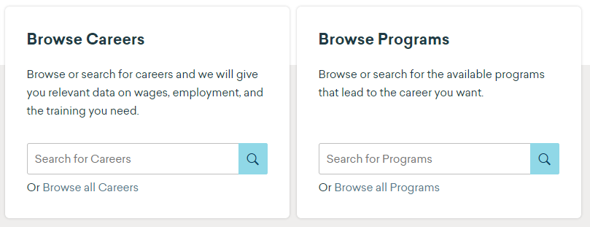

**Browse Careers** to learn all about expected earnings, available jobs, daily tasks, job postings, top employers, relevant skills and more.

**Browse Programs** to see the TCC educational paths that will prepare you for your career of interest. You can apply right away!

Career Coach Worksheet

As you work through the assessment, you will have the opportunity to “Add” potential careers to your profile for later review.

**NOTE:** At the end of each assessment, you will be provided results that will help you complete the worksheet. Your results are NOT saved to your profile, unless you select the Sign Up button located at the top right hand corner of the screen. If you do not sign up please make sure to fill in the following information before exiting the results page.

**INTEREST ASSESSMENT**

During the assessment, you will be asked to determine which activities interest you. Use the space below to list **TWO** activities that you are very interested in doing from those presented during the assessment.

**Interesting Activities:** Click here to enter text.

At the end of this assessment, you will be provided with your top three traits. Use the space below to identify your top three traits (interest codes)

**Primary Trait:** Click here to enter text.

**Second Trait:** Click here to enter text.

**Third Trait:** Click here to enter text.

**TOP CAREER CLUSTERS**

At the end of this assessment, you will be provided with a list of career clusters that match your interests. Use the space below to list at least **TWO** career clusters from your results. (You may write in more than two).

**Career Cluster:** Click here to enter text.

**Career Cluster:** Click here to enter text.

**Career Cluster:** Click here to enter text.

Career Coach Worksheet - Continued

**TOP CAREER MATCHES**

Use the space below to list your most interesting career cluster.

**Most Interesting Career Cluster:** Click here to enter text.

Next select the career cluster link to identify specific careers of interest. Use the space to select the most interesting careers associated with your career cluster (You may write in more than two).

**Primary Career of Interest:** Click here to enter text.

**Secondary Career of Interest:** Click here to enter text.

**Third Career of Interest:** Click here to enter text.

**ASSESSMENTS SUMMARY**

At this point in your life and academic career, you may know exactly what career you want to pursue, you may already be in your career, and you may have no idea what career path you will take after graduating.

Use the space below to reflect on the results from the Assessment. Are the results surprising? Are they in line with the career you want to pursue? What does the assessment tell you about yourself and your future career? How will you use these results in directing your academic progress? Your response should be at least one paragraph.

**Summary:** Click here to enter text.